Peer-to-Peer Learning Platform
A Time-Based Knowledge Exchange System
1. Introduction:
The Peer-to-Peer Learning Platform is a live, time-based knowledge exchange system that enables users to both learn and teach skills without monetary transactions.
The platform is designed to solve a key problem:
Many students cannot afford paid online courses, while many skilled individuals want to share knowledge but lack accessible opportunities.
This platform creates a credit-based learning economy, where users earn points by teaching and spend points to learn from others.
The system supports:
- One-to-one live sessions
- Real-time point transactions
- AI-based skill validation
- Reputation-based ranking
The platform is open to students, professionals, and lifelong learners.
2. Problem Statement:
- Online courses are often expensive.
- Many learners lack access to quality personalized tutoring.
- Skilled individuals struggle to monetize or exchange knowledge.
- Most platforms focus only on paid models.
There is a need for a fair, skill-based, non-monetary learning ecosystem.
3. Proposed Solution:
The platform introduces a Time-Based Credit System, where:
- Users earn credits by teaching.
- Users spend credits to learn.
- Points are automatically transferred based on session duration.
- AI validates subject expertise and maintains quality standards.
This creates a self-sustaining knowledge economy.
4. Core Features:
4.1 User Roles
- Learner – Books sessions and spends points.
- Teacher – Conducts sessions and earns points.
- Admin – Monitors system and manages disputes.
Users can act as both learner and teacher.
4.2 Live One-to-One Sessions
- Real-time video/audio sessions.
- Screen sharing support.
- Interactive whiteboard (future scope).
- Session timer tracking duration.
Unlike platforms such as Udemy or Coursera, this platform focuses only on live interactive sessions, not pre-recorded content.
4.3 Time-Based Point System
Points are exchanged automatically when a session ends.
- 1 minute = 0.4 points
- 15 minutes = 6 points
- Learner spends points
- Teacher earns points
The system ensures:
- Transparent transactions
- Automatic calculation
- No manual intervention
4.4 AI-Based Skill Validation
To maintain quality, the platform uses AI to:
- Conduct pre-session knowledge tests.
- Analyze session feedback and ratings.
- Evaluate quiz performance of learners.
- Rank teachers based on:
  - Accuracy
  - Feedback score
  - Teaching consistency
  - Subject expertise score
This prevents misinformation and ensures trusted learning.
4.5 Rating and Reputation System
After each session:
- Learners rate teachers.
- Teachers rate learners.
- AI updates credibility score.
- Rankings affect visibility in search results.
5. System Architecture Overview:
Frontend
- React.js (Web Interface)
- Responsive UI
- Dashboard for points and sessions
Backend
- Node.js / Express or Django
- REST API
- Authentication & Authorization (JWT)
Database
- PostgreSQL / MongoDB
- User profiles
- Session history
- Points ledger
- Rating records
Real-Time Communication
- WebRTC for live sessions
- Socket.io for signaling and session control
AI Integration
- NLP-based evaluation
- Quiz engine
- Performance scoring model
6. Workflow:
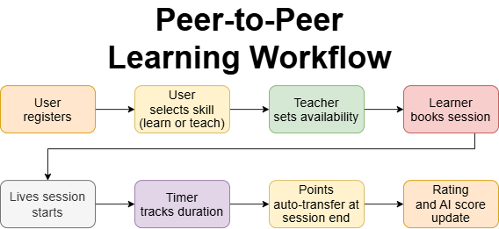
7. Database Design:
Main Tables:
- Users
- Skills
- Sessions
- Points_Transactions
- Ratings
- AI_Score
8. Security & Fairness Mechanisms:
- JWT Authentication
- Encrypted session communication
- Fraud detection (fake sessions prevention)
- AI-based anomaly detection
- Session recording (optional future feature)
9. Future Enhancements:
- Group sessions
- Mobile application
- Skill certification badges
- Blockchain-based credit tracking
- Premium mentorship tiers
- Corporate learning programs
10. Target Audience:
- University students
- Job seekers
- Professionals
- Freelancers
- Career switchers
11. Competitive Positioning:
Platform | Model | Live | Skill Exchange
Udemy | Paid Courses | ❌ | ❌
Coursera | Subscription | ❌ | ❌
Preply | Paid 1-1 | ✅ | ❌
This Platform | Time-Based Credit | ✅ | ✅
12. Impact:
- Removes financial barriers to education.
- Encourages collaborative learning.
- Rewards knowledge sharing.
- Builds community-driven growth.
13. Conclusion:
The Peer-to-Peer Learning Platform introduces a sustainable, AI-enhanced, time-based learning economy. By eliminating direct monetary transactions and enabling skill exchange, the system empowers learners and educators equally.

